Spark Ultimate

Basic Hadoop commands: -

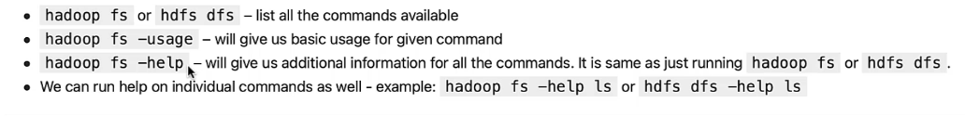

List all the available commands with their details: -



Listing basic usages and the syntax of all commands: -



Details for a specific command: -

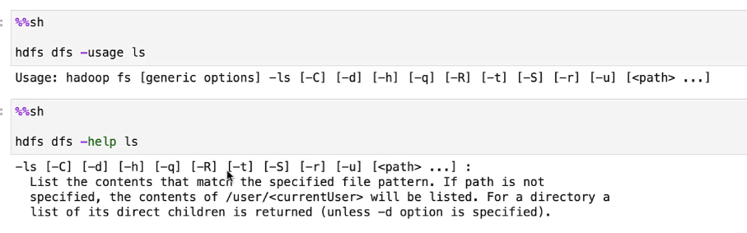

Reverse the order of sort of the ls command output: -





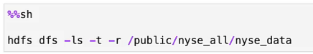



Creating a folder structure: -

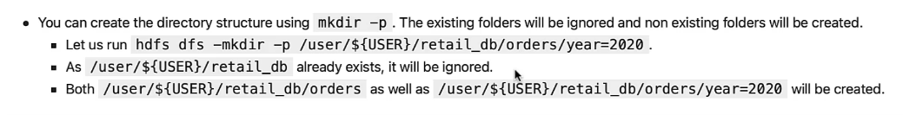

Deleting folder: -





Copy files from Local to HDFS: -

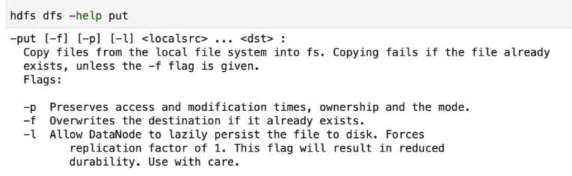

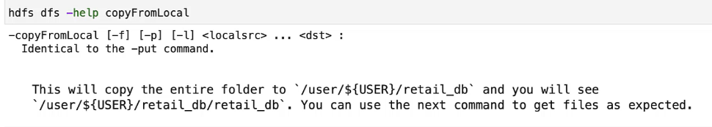

Using wild cards / patterns: -

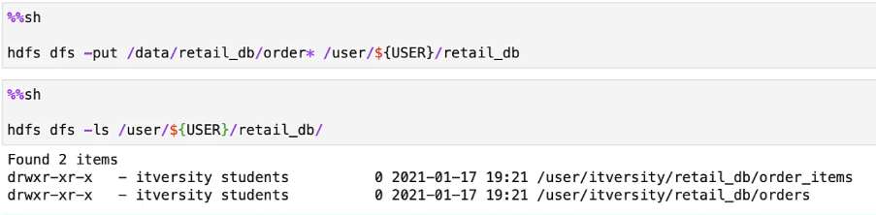

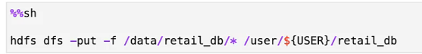

* Already existing folders will be replaced

Validation: -

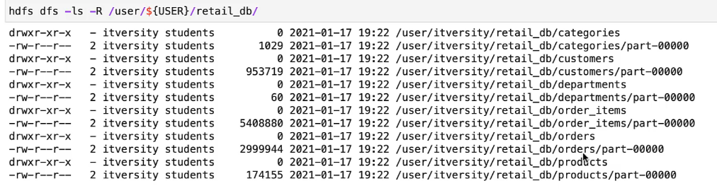



Copy files from HDFS to local: -

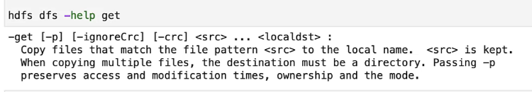

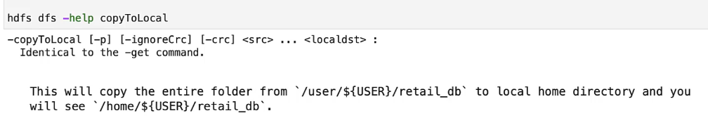



* If some files or folders are already present it will copy only the nonsexist ones

Getting file metadata: -

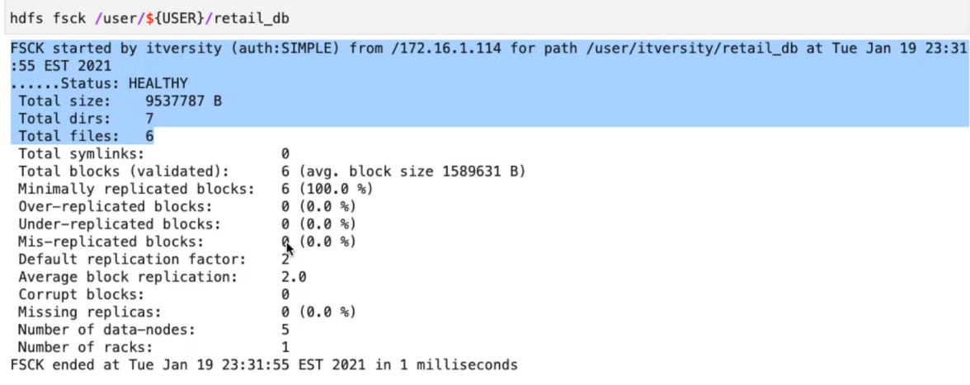

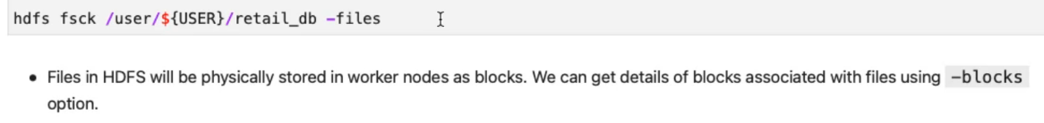





Previewing data in HDFS: -

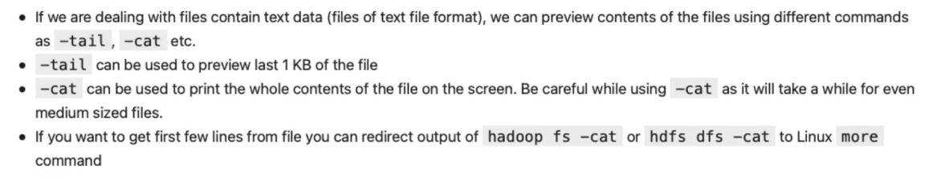

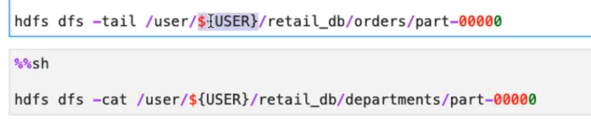

* Cat supports patterns but tail doesn’t

Replication factor: -

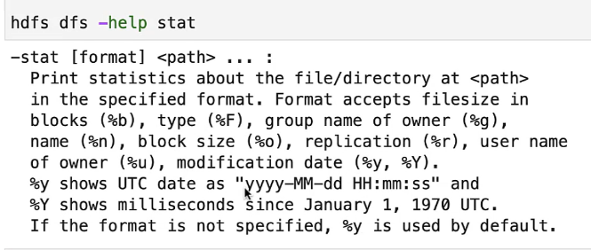

Getting HDFS storage usage: -

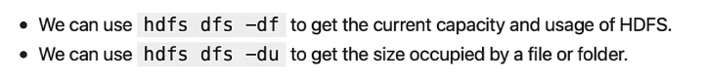

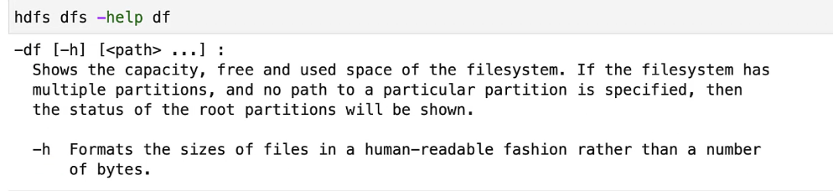

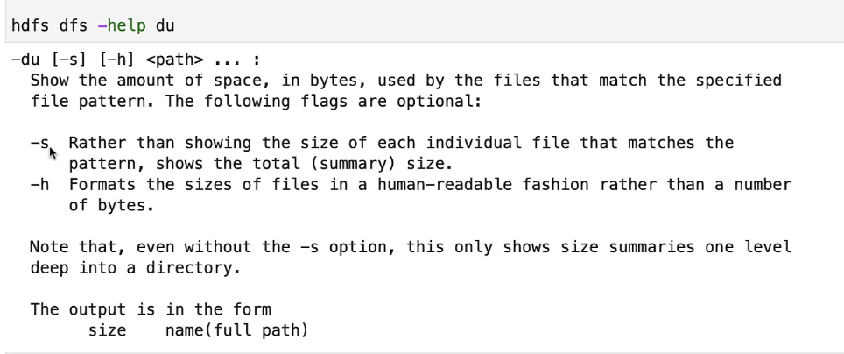

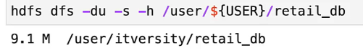

HDFS file permissions: -



* u 🡪 user
* g 🡪 group
* o 🡪 others

Overriding the properties: -



Spark

Getting help form spark shell: -



Creating rdd from a text file and minPartitions: -



* If you specify less number in ‘minPartitions’ bydefault it will submit actual number of partitions as number of jobs

Creating a dataframe: -

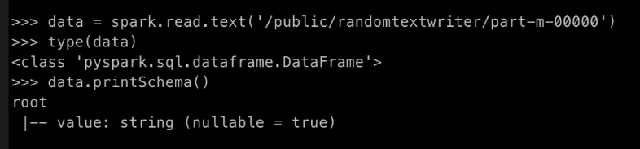

Word count problem RDD: -

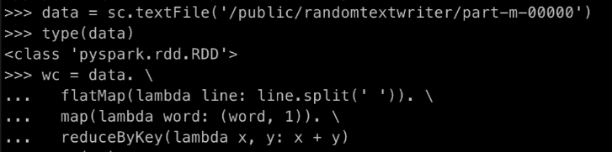

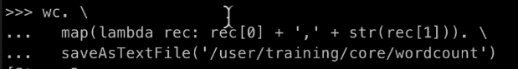

Word count problem Dataframe: -

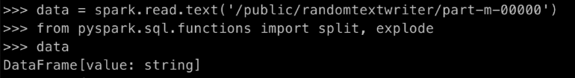

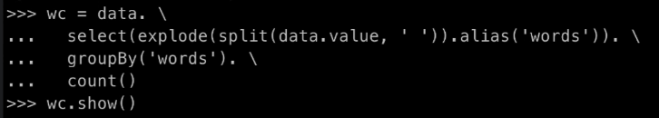



Reading data and attaching schema: -

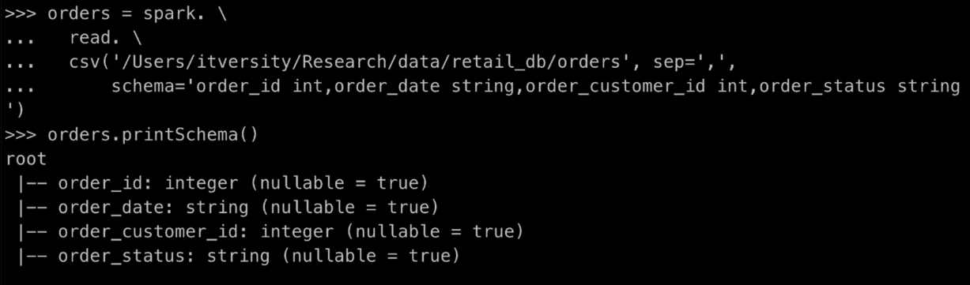

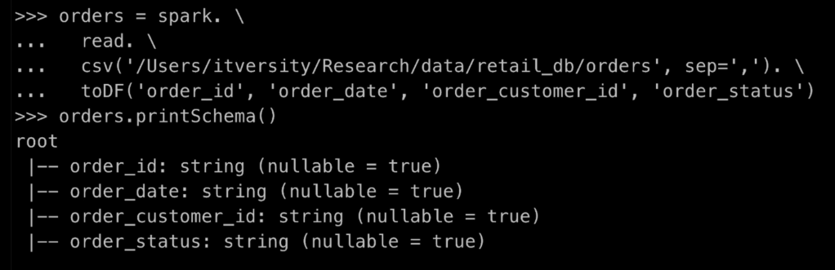

* It will not change the datatype

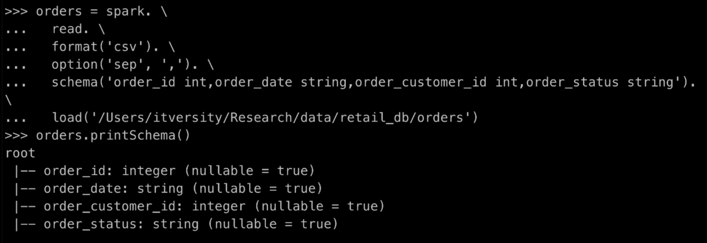

Type Casting: -





* Type casting without selecting all columns

Reading Hive Table from Spark: -

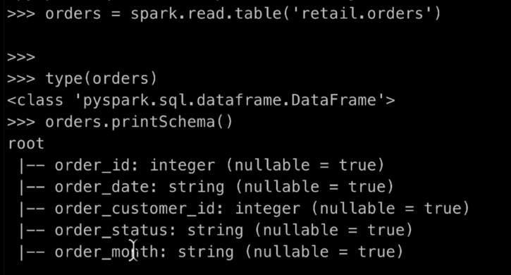

* You can use it if you already have hive and spark connectivity

Spark SQL

If we are using Pyspark the command will be spark.sql(“the command”).show()

Showing current database: -

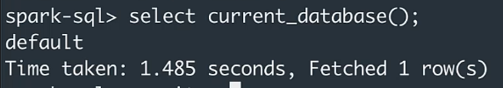

Shuffle partitions: -

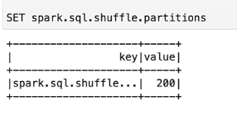

Spark meta store database: -

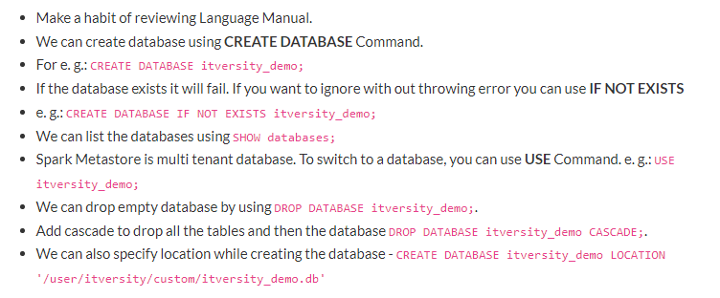

Creating a database: -





Creating a spark table: -

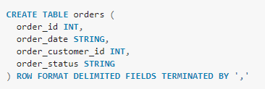

Retrieving metadata of a table: -

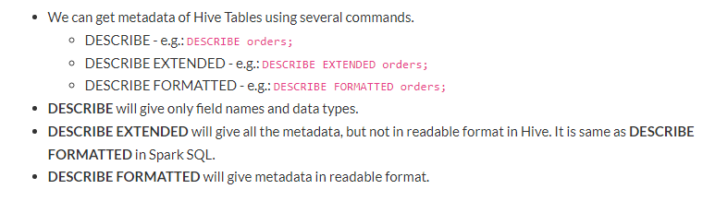

Role of Spark Metastore or Hive Metastore: -

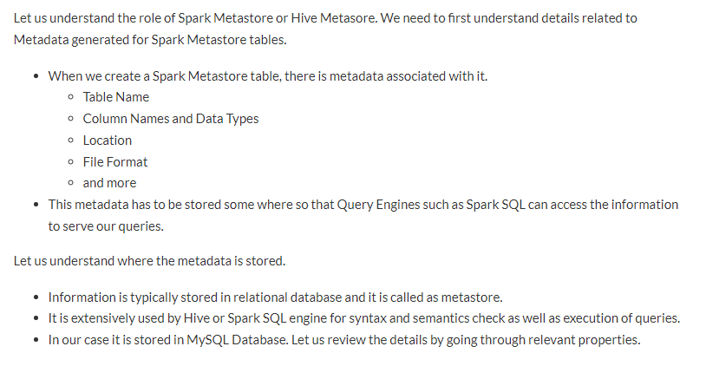

Problem statement: -

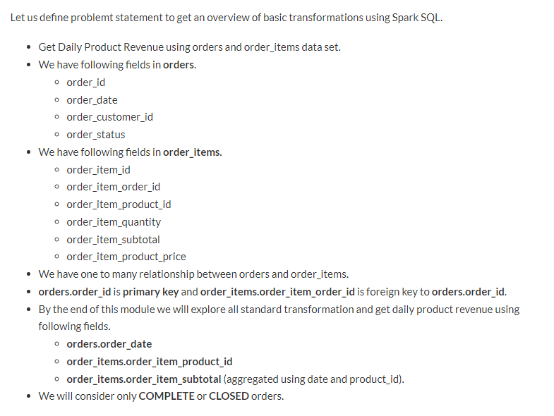

Creating orders table: -

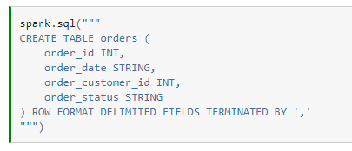

Load data: -



Creating order_items: -

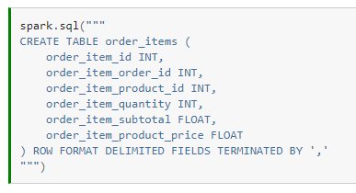

Load data: -



Data processing using Spark – The Pythonic way

Creating a Spark session: -



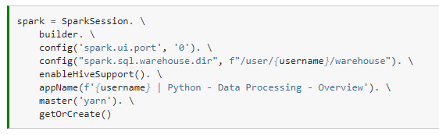

Read APIs: -

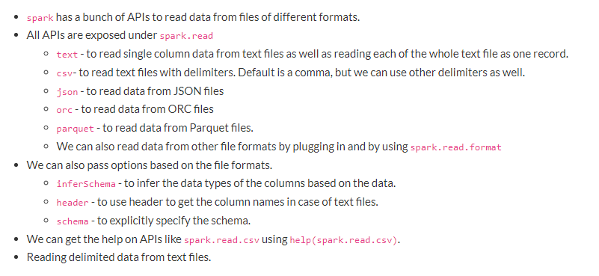

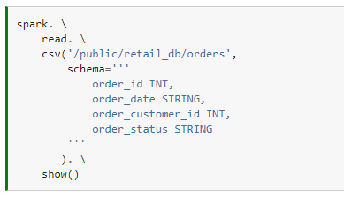

Infer schema: -

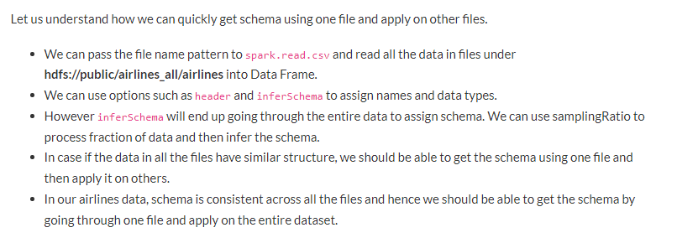

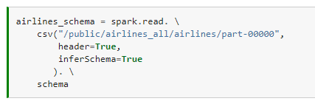

* If we use it along with the samplingRatio it will be better



* Airlines_part_00000 is a dataframe

Distinct count: -



Spark DataFrame API: -

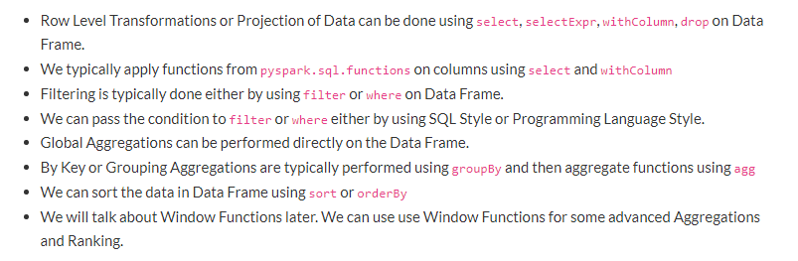

Creating a DataFrame from collection: -

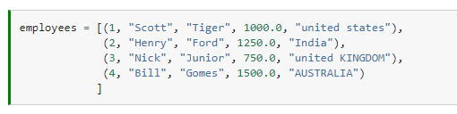

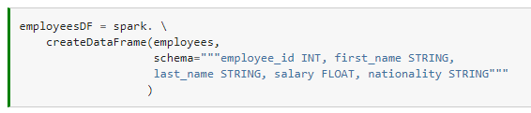

Few operations: -

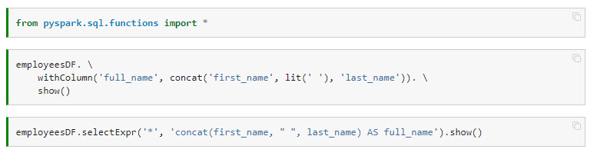

* If you are doing it in programmatic way lit() function is important. Otherwise it will search for a column named ‘ ’ and won’t able to find it and fail

Overview of Functions: -

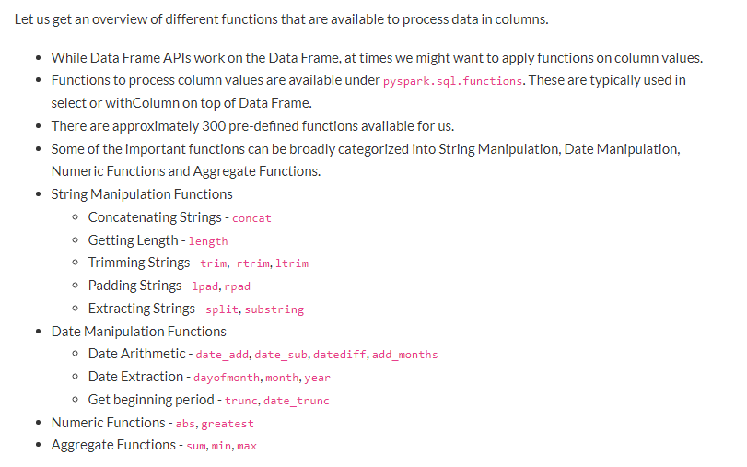

Overview of Spark write APIs: -

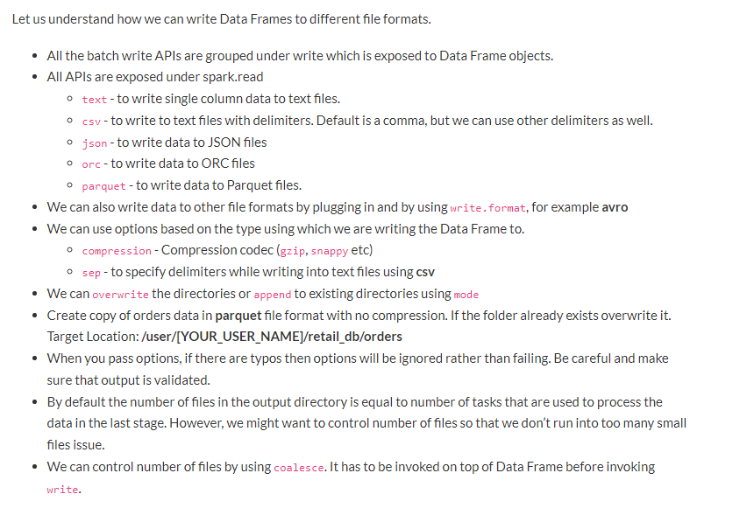

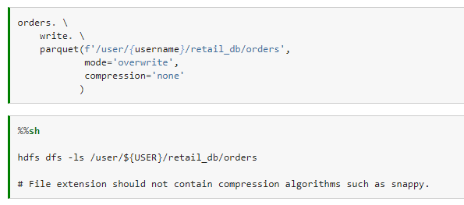

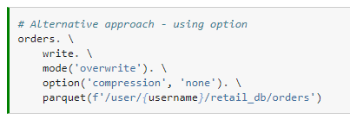

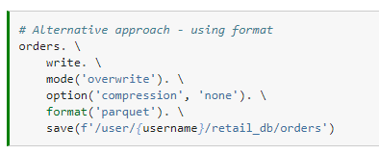

Coalesce: -

